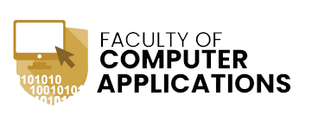

**A Python Project for Academic Year 2025 - 2026**

**Employee management System**

Subject Name: mini project

Submitted By: Hemik hirani

[92300527192]

Submitted By:Vipul mundhava[92300527187]

Submitted By:jaimin vala[92420527006]

Submitted To: Prof. tirth bhadesiya

**Introduction**

* The Employee Payroll System is a Python-based application developed to manage employee data and attendance records.
* It uses CSV files for data storage, allowing easy manipulation without the need for external databases.
* The system is entirely command-line based and offers a user-friendly menu interface.

**Technical information**

**Technologies used:**

* Programming language: python 3.x
* Data storage: csv files
* Libraries: csv, os

**Development tools:**

* ide: vs code / pycharm / any python-supported editor
* Execution environment: cli / terminal

**System requirements**

**Software:**

* Python 3.x
* Any text editor or ide
* Cli for execution

**Hardware:**

* Any system running python
* Minimum 512mb ram
* Minimal disk space for csv storage

**Project structure**

**Main script:**

* Employee_payroll.py (contains all logic)

**Csv files:**

* Employee_payroll.csv (stores employee data)
* Employee_attendance.csv (stores attendance records)

**DIGRAM**

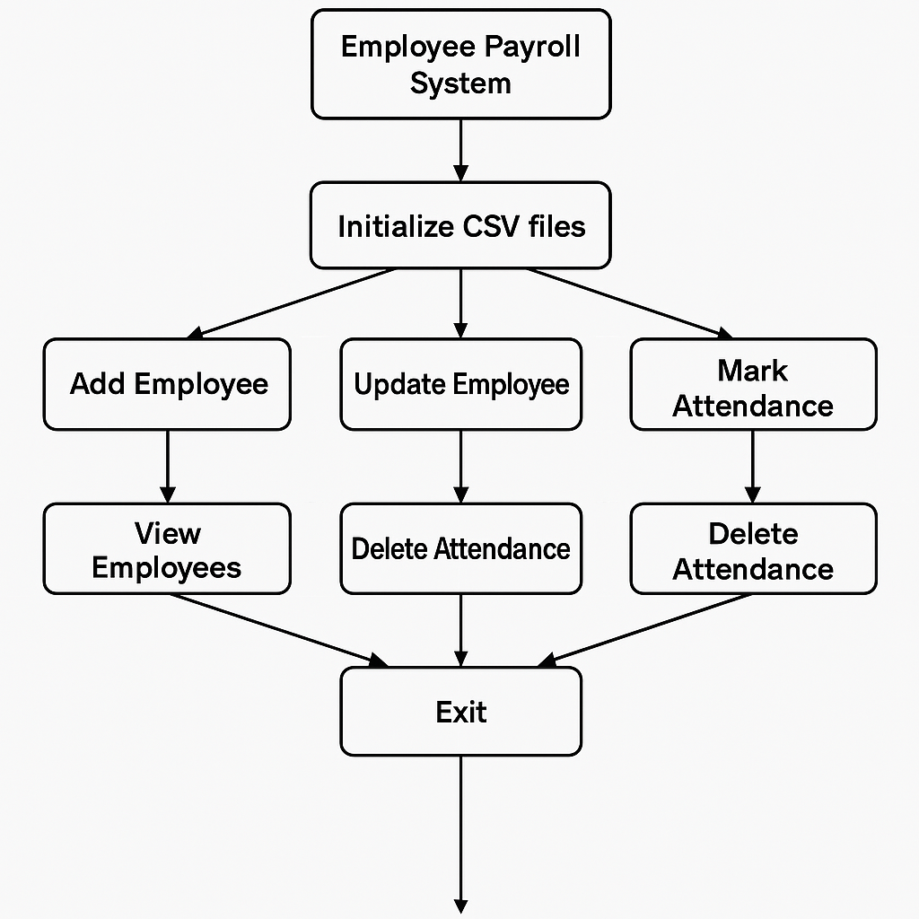

**Features**

* Add, view, update, delete employees
* Mark, view, delete attendance
* Input validation for phone, age, gender
* Csv file auto-creation
* Simple menu-driven interface

**Output Screenshots**

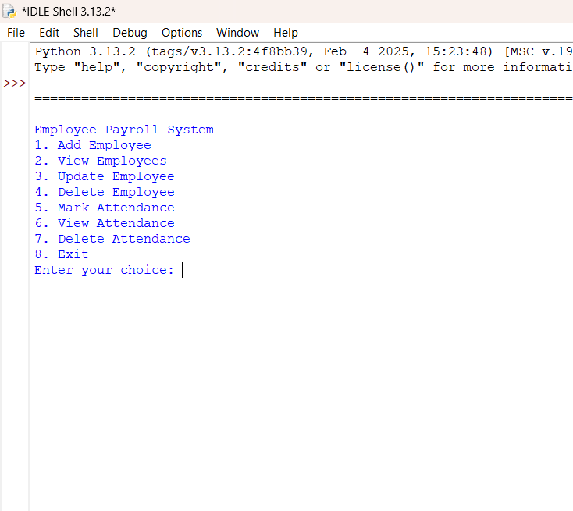

**MAIN MENU**

**Adding a employee**

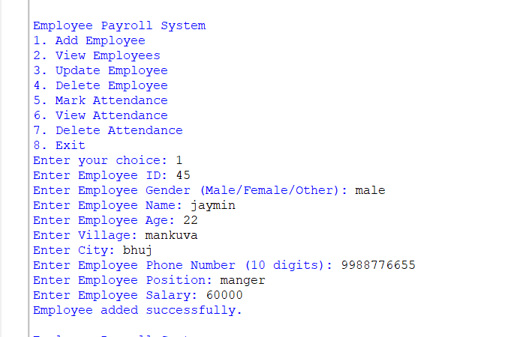

**View All employee**

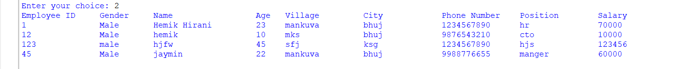

**Update employee Details**

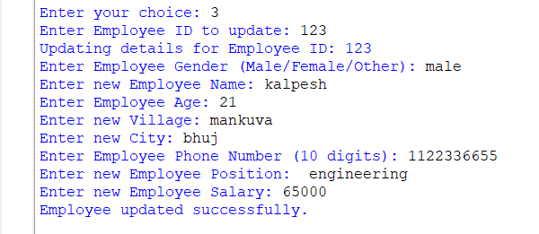

**Delete employee**

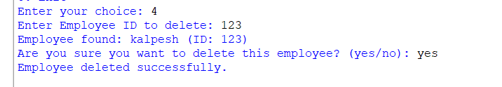

**Mark Attendance**

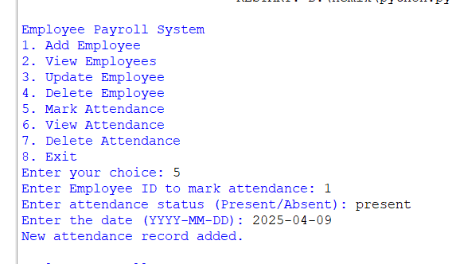

**View Attendance**

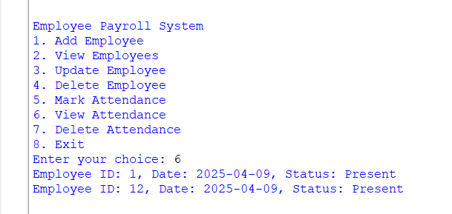

**Delete Attendance**

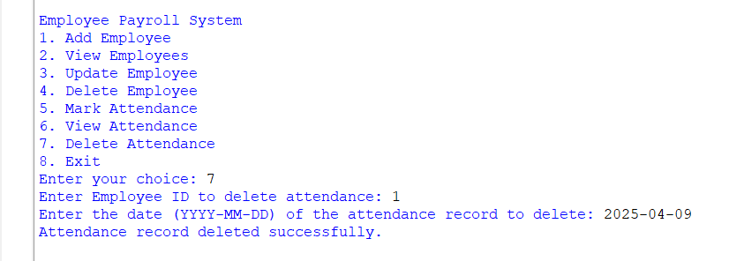

**Learning Objectives**

* Python file handling with csv
* Data Validation and User Input
* Crud operations
* Attendance Tracking
* Modular programming structure

**Conclusion**

* This project provided hands-on experience in building a functional cli-based system using core python features.
* It helped in understanding file operations, data validation, and user-friendly program design.
* Future improvements may include gui integration and database support.

the end